QUERY WITH JOINS – EQUIJOIN, INNERJOIN, OUTERJOIN

NAME: SMOHIT ARMAN SWAIN
REG NO: 192572092

GIVEN RELATION:

1)

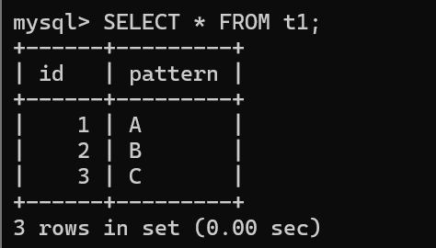

2)

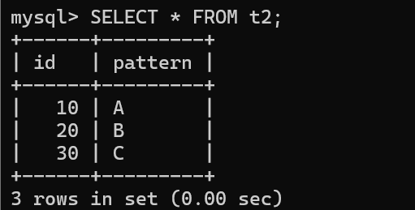

JOINS:

CROSS JOIN:

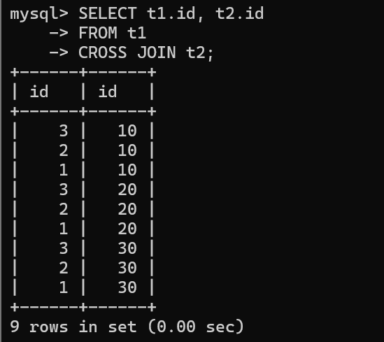

INNER JOIN:

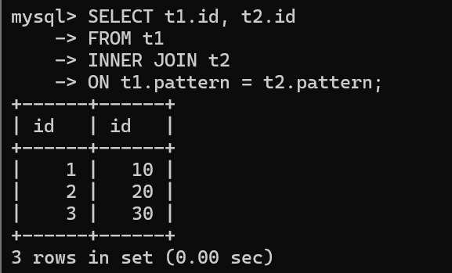

LEFT JOIN:
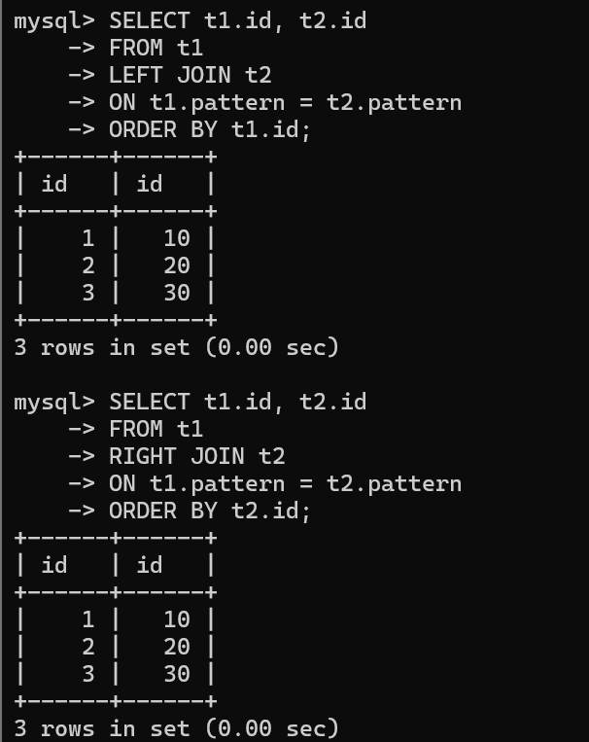

RIGHT JOIN:



